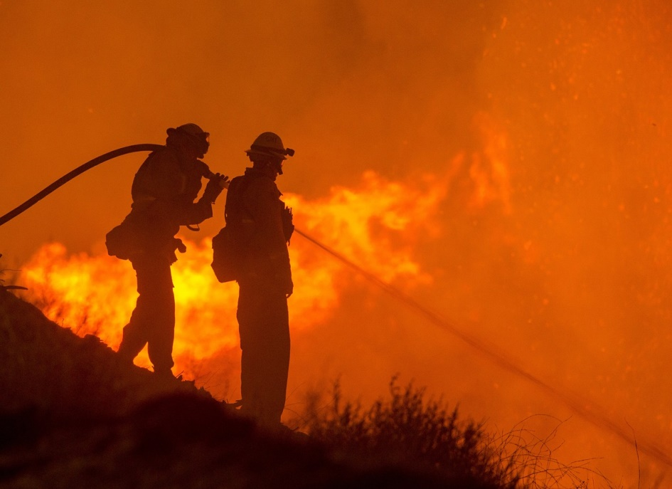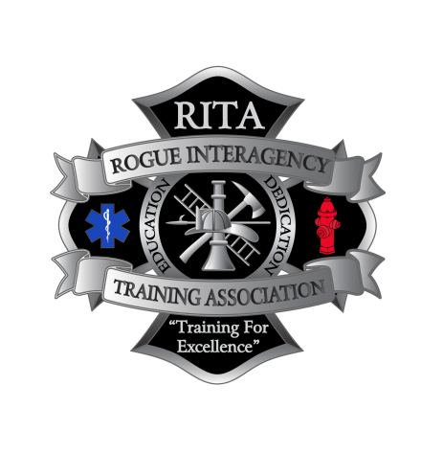

**Register online @ orrita.com**

**Saturday November 14th, 2020**

**0800-1800**

**$25**

**S-131 Firefighter Type 1 / Incident Commander Type 5**

**Applegate Valley Fire District Training Building**

**1095 Upper Applegate Rd.**

**Jacksonville, OR 97530**

S-131, Firefighter Type 1 is designed to meet the training needs of the Firefighter Type 1 (FFT1) and/or Incident Commander Type 5 (ICT5).

Prerequisite Training: Students should already be trained the Wildland Firefighter Type 2 level with some experience under their belt.

We will be following COVID-19 best practices, so be prepared by: bringing a mask to class, practicing social distancing, and do not come to class if you are experiencing COVID type symptoms or have been exposed to a known active COVID patient in the previous 14 days.

Please bring a sack lunch and any other food items that you will need for the duration of the class, as restaurant and store opportunities are sparse in the Applegate. Students will not have access to the kitchen facilities due to COVID-19 concerns.

**S-131 FIREFIGHTER TYPE 1**